43.49: Nuclei: 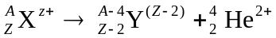
Add the mass of  electrons to each side and we find: 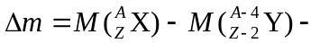
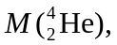 where now we have the mass of the neutral atoms. So as long as the mass of the original neutral atom is greater than the sum of the neutral products masses, the decay can happen.

